The Principle of Family Unity for Refugees in Switzerland
–
Are International Human Rights Standards Applied?

Conference
Bern, 21 November 2017

Background note

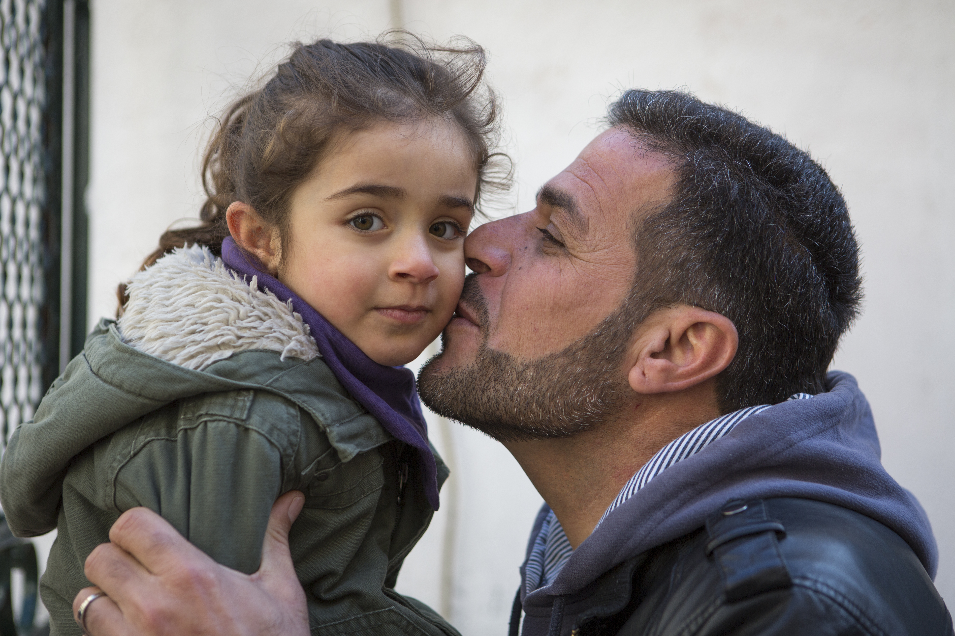
© UNHCR/Yorgos Kyvernitis

Background
Flight, be it from persecution or conflict, comes along with many sufferings. The separation of families is often among those most difficult to bear. The loss of contact with family members may disrupt the major remaining source of protection and care or, equally distressing, put out of reach those for whose protection a refugee feels most deeply responsible. Ensuring family reunification is therefore a fundamental aspect of bringing normality back to the lives of the persons concerned and is an indispensable premise for the successful integration of refugees.
The principle of family unity as a core principle of international refugee law provides refugees with a legal framework to achieve this goal. It is based on and translates the right to family life protected by many international human rights treaties such as the International Covenant on Civil and Political Rights, the Convention on the Rights of the Child or the European Convention on Human Rights into the refugee context.
The right to family life is not only protected by international law, but also incorporated into the Swiss Federal Constitution, which recognizes the importance of the right to family life for all individuals in Switzerland, irrespective of their nationality or legal status. Despite the strong anchorage in international and national law, the right has been increasingly restricted for refugees over the past years. Today, legal and practical obstacles prevent many refugees from being reunited with their families in Switzerland. This concerns particularly, but not exclusively refugees who have been recognized as Convention refugees but only granted a provisional admission («provisionally admitted refugees»), and refugees who have not been recognized as such and merely granted a provisional admission («provisionally admitted foreigners»).

Objectives
The Conference will
- provide an overview of the situation of separated refugee families, and of trends and initiatives related to family reunification in Europe
- review the implications of family separation on refugees, particularly on refugee children
- examine how the right to family life, including the right to family reunification, is guaranteed by international human rights and refugee law standards
- analyse whether Swiss law and practice regarding family reunification are compatible with those standards
- explore how identified obstacles could be addressed, including through strategic litigation.

Convener and Host
The Swiss Advocacy Centre for Migrants’ Rights (CSDM) co-organises this Conference together with the UNHCR Office for Switzerland and Liechtenstein.
For any questions, please contact:
- Ms Jasmine Caye, CSDM, jcaye@centre-csdm.org
- Ms Muriel Trummer, UNHCR, trummer@unhcr.org

Venue and Date
The Conference will take place on 21 November 2017 from 14h00 - 18h00 at the Novotel Bern Expo (Guisanplatz 4, 3014 Bern).
From the train station, take tram number 9 towards Guisanplatz Expo (16 minutes): https://map.search.ch/Bern,Bahnhof-Haltestelle..Novotel-Bern-Expo?mode=oev&time_type=depart&z=128.

Participation and Cost
The Conference is public and participation is free of charge. Invitations are sent to government and public officials, judges, lawyers, academics, and civil society representatives with experience in family reunification cases.
Please note that places are limited and will be allocated on a first come, first served basis. For organizational reasons, registration for the Conference will be closed after 3 November 2017.

Languages
Presentations and discussions are translated into German and English (simultaneous interpretation offered). Please indicate your needs on the registration form.

Draft Agenda
14h00 – 14h05 Welcome and Introduction (CSDM)
14h05 – 14h25 Family Reunification of Refugees in Europe – Setting the Scene
Nils Muižnieks, Council of Europe Commissioner for Human Rights (English)
14h25 – 14h45 Questions
14h45 – 15h05 The Principle of Family Unity in International Refugee Law (working title)
Madeline Garlick, Senior Legal Coordinator and Head of Protection Policy and Legal Advice, UNHCR (English)
15h05 – 15h15 Questions
15h15 – 15h45 Family Reunification of Refugees in Switzerland and International Human Rights Standards
Stephanie Motz, Advisory Board CSDM, Barrister and Ph.D. Candidate, University of Lucerne (German)
15h45 - 15h55 Questions
15h55 – 16h20 Coffee Break
16h20 – 16h40 Family Reunification: Practical Obstacles (working title)
Vanessa Ballarin, Deputy Head of Migration Department, Swiss Red Cross (German)
16h40 – 16h50 Questions
16h50 – 17h10 Separated Families – The Impact on Children Left Behind (working title)
Areti Sianni, Senior Protection Advisor (MENA), UNHCR (English)
17h10 – 17h20 Questions
17h20 – 17h30 Closing Remarks and End of Workshop (UNHCR)
17h30 – 18h00 Apéro

